US ARMY CYBER and ELECTROMAGNETIC WARFARE SCHOOL
Cyber Training, Education, and Development Division
Cyber Captains Career Course
Information Advantage Paper

Course Author: MAJ Nelson Godbolt
Lesson Author: MAJ Nelson Godbolt
Date Prepared: 15 December 2023

1. SCOPE

The Information Advantage paper requires students to write an at least five-page paper on the articles and presentations from the University of Augusta engagements.

2. LEARNING OBJECTIVES

TERMINAL LEARNING OBJ
Action: Write an at least five-page paper, not including title or reference page, on one of the following prompts:
- Pick one article presented and explain the potential impacts /findings of the arguments on the future of the branch? Explain what the DoD can do to better the outcome.
- Pick one article and write a cause-and-effect essay detailing potential outcomes if the article findings come true. Project what the worst and best outcomes could be and what the DoD failed to do or did to change the outcome.
OR
With Cadre approval, write a five-page essay on Information Warfare, Information Advantage, and what the branch should do.

Condition: Using research, study, reflective thinking, references, this advance sheet, write an unclassified paper as described above.

Standard: See Appendix A, Examination Plan.

Learning Domain: Cognitive
Level of Learning: Apply
Instructor Competencies Supported: 3, 9, 10, 11
Army General Learning Outcomes Supported: 2, 3, 4, 5, 7,9, 13, and 14

3. MODULE ASSESSMENT PLAN: (See Appendix A)

4. ISSUE MATERIAL: None

5. ADDITIONAL MODULE REQUIREMENTS. None
US ARMY CYBER and ELECTROMAGNETIC WARFARE SCHOOL
Cyber Training, Education, and Development Division
Cyber Captains Career Course
Information Advantage Paper

Appendix A
Assessment Plan

Assessment Plan: Student will not include their name to prevent grading bias. Graders will consult a secondary grader for grades below 80% and above 95%. Feedback will be based on ST-22-2 Leader Communication. See ST 22-2 Appendix A for guidance on formatting and Appendix C for guidance on acronyms, numbers, pronouns, and etc.

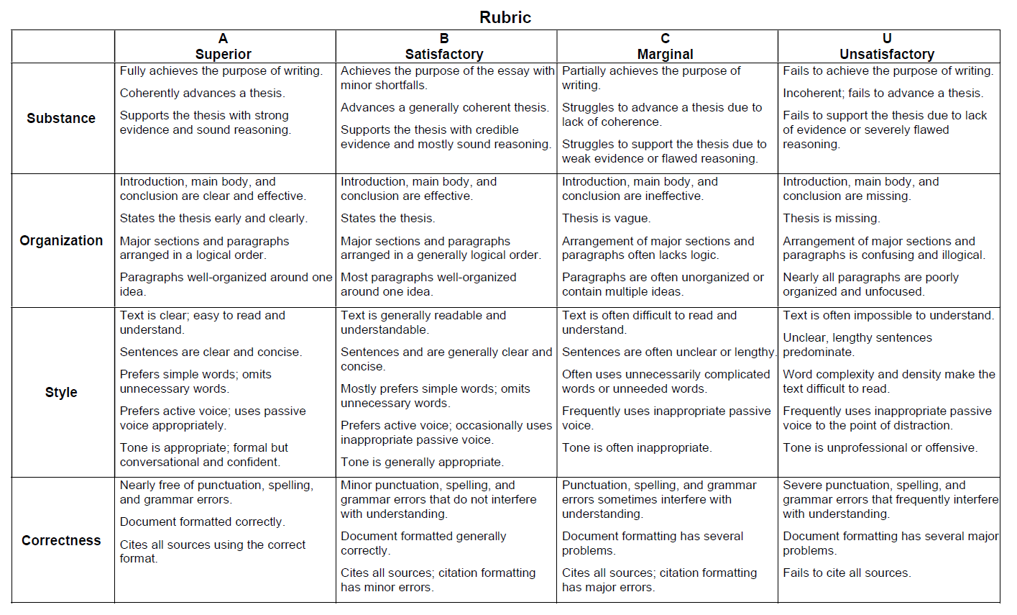
Substance and Organization are each weighted at 30% of the overall grade, with Style and Correctness each weighted at 20%. However, if the style and correctness overly detracts from the reader’s ability to understand the paper, a mandatory re-write is required. *Lack of citations will also result in an automatic re-write.

GRADE POINT AVERAGES (GPA). The following table supports the letter-numeric conversions and corresponding grading ranges:

Letter Grade | Grading Range
A+ | 97-100
A | 94-96.9
A- | 90-93.9
B+ | 87-89.9
B | 84-86.9
B- | 80-83.9
C+ | 77-79.9
C | 74-76.9
C- | 70-73.9
UNSAT | 0-69.9

